**Text CSS**

1. Text Color

* Text color property is used to color the text.

1. Text Alignment

* The text-align property is used to set the horizontal alignment of a text.
* A text can be left or right aligned, centered, or justified, start and end.
* When the text-align property is set to "justify", each line is stretched so that every line has equal width, and the left and right margins are straight (like in magazines and newspapers):

1. Text Alignment Last

* It specifies how to align the last line of a text(text starts from last line)

Ex

p{text-align-last: right;}

p {text-align-last: center;}

p { text-align-last: justify;}

1. Vertical Alignment

* The vertical-align property sets the vertical alignment of an element.

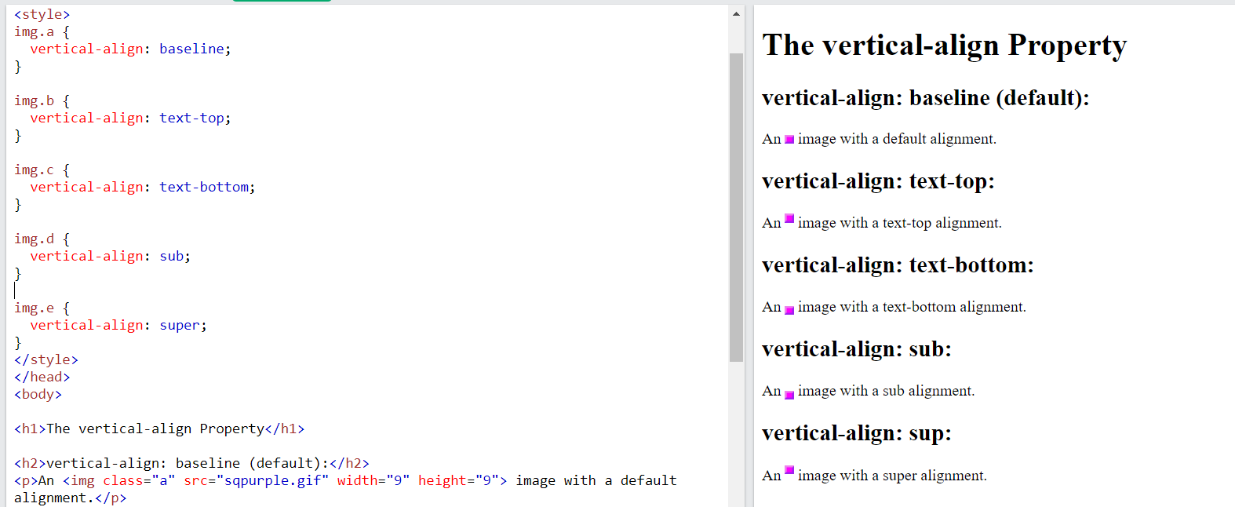

1. Text decoration Line

* The text-decoration-line property is used to add a decoration line to text.

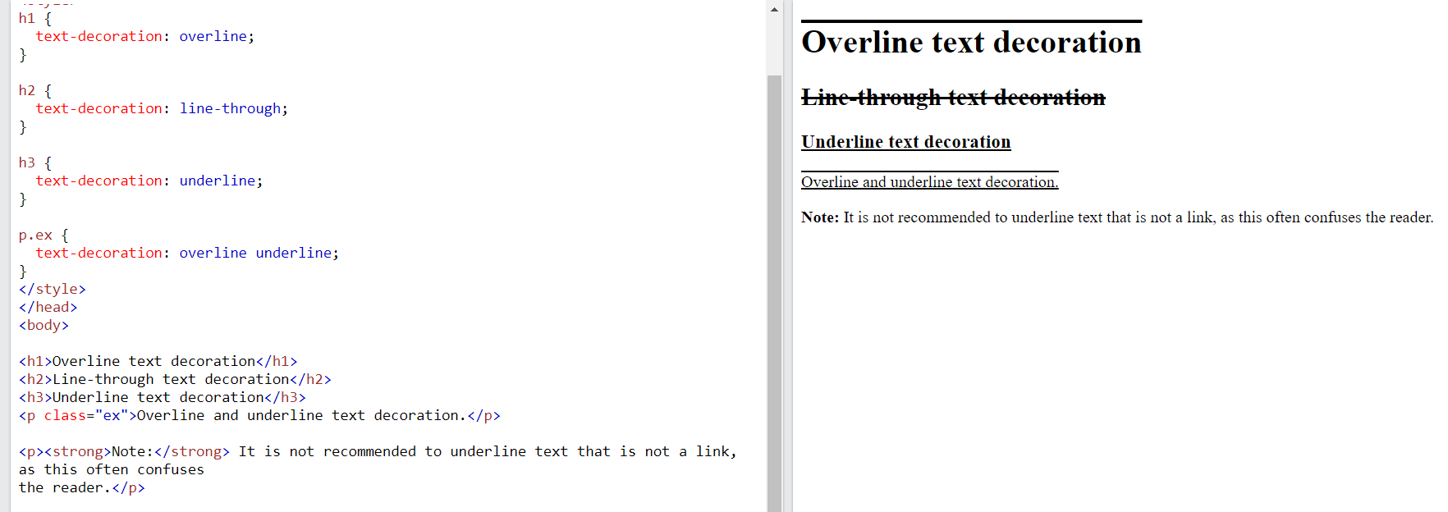

|  |  |
| --- | --- |
| [text-decoration](https://www.w3schools.com/cssref/pr_text_text-decoration.asp) | Sets all the text-decoration properties in one declaration |
| [text-decoration-color](https://www.w3schools.com/cssref/css3_pr_text-decoration-color.asp) | Specifies the color of the text-decoration |
| [text-decoration-line](https://www.w3schools.com/cssref/css3_pr_text-decoration-line.asp) | Specifies the kind of text decoration to be used (underline, overline, etc.) |
| [text-decoration-style](https://www.w3schools.com/cssref/css3_pr_text-decoration-style.asp) | Specifies the style of the text decoration (solid, dotted, etc.) |
| [text-decoration-thickness](https://www.w3schools.com/cssref/pr_text_text-decoration-thickness.asp) | Specifies the thickness of the text decoration line |

1. Text Transform

* The text-transform property is used to specify uppercase and lowercase letters in a text.

1. Text Spacing

|  |  |
| --- | --- |
| **Property** | **Description** |
| [letter-spacing](https://www.w3schools.com/cssref/pr_text_letter-spacing.asp) | Specifies the space between characters in a text |
| [line-height](https://www.w3schools.com/cssref/pr_dim_line-height.asp) | Specifies the line height |
| [text-indent](https://www.w3schools.com/cssref/pr_text_text-indent.asp) | Specifies the indentation of the first line in a text-block |
| [white-space](https://www.w3schools.com/cssref/pr_text_white-space.asp) | Specifies how to handle white-space inside an element |
| [word-spacing](https://www.w3schools.com/cssref/pr_text_word-spacing.asp) | Specifies the space between words in a text |

1. Text Shadow

* The text-shadow property adds shadow to text.

